Linatoc, Lian Mark S.
DC 101/ CC 105
BSCS 2C
Lost and Found Management System

1. Introduction
The Lost and Found Management System is a web-based application designed to help manage, record, and track lost and found items within an organization such as a school or office. The purpose of the system is to provide an organized and efficient way of storing information about lost and found items, reducing confusion and improving the chances of recovering lost belongings.
This system allows users to add new records, view existing items, update item details, and delete records when items are claimed. By integrating database management with web development, the system demonstrates how data can be stored, retrieved, and manipulated dynamically using a web interface.
2. Database Design
2.1 Database Overview
The system uses a MySQL database named:
lost_and_found_db
The database consists of three related tables:
- users
- categories
- items
2.2 ER Diagram (Text Description)
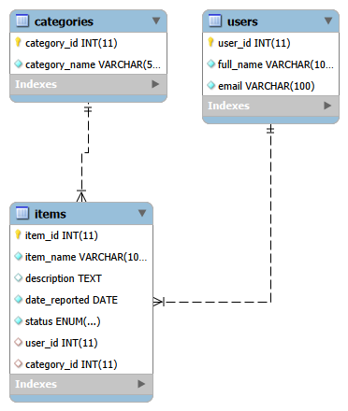
- One User can report many Items
- One Category can have many Items
- Each Item is reported by one User and belongs to one Category
Relationships:
- users (1) —— (M) items
- categories (1) —— (M) items
2.3 Table Descriptions
Table: users
Field Name | Data Type | Description
user_id | INT (PK) | Unique ID of the user
full_name | VARCHAR(100) | Name of the user
email | VARCHAR(100) | User email addresse

Table: categories
Field Name | Data Type | Description
category_id | INT (PK) | Unique category ID
category_name | VARCHAR(50) | Item category

Table: items
Field Name | Data Type | Description
 | INT (PK) | Unique item ID
  item_id
item_name | VARCHAR(100) | Name of the item
description | TEXT
  Item description
 | DATE | Date the item was reported
  date_reported | DATE
status | ENUM | Lost or Found
user_id | INT (FK) | References users table
category_id | INT (FK) | References categories table

3. Web Interface
3.1 Key Pages
Main Page (index.php)
- Displays the system title
- Contains a form to add new lost or found items
- Displays all recorded items in a table format
- Provides Edit and Delete buttons for each record

Edit Page (edit.php)
- Loads the selected item’s information
- Allows users to update item details such as name, description, date, and status

3.2 Key Functionalities
- Add Item: Users can add new lost or found items using a form.
- View Items: All items are displayed dynamically from the database.
- Edit Item: Users can update existing records.
- Delete Item: Users can remove records when items are no longer needed.
- JavaScript Validation: Ensures proper input before form submission.

4. Challenges and Learning

Challenges
One of the main challenges encountered was correctly connecting the MySQL database to the web interface using PHP. Implementing the update and delete functions also required careful handling of PHP syntax and SQL queries.

Learning
Through this project, I gained a deeper understanding of how databases work with web applications. I learned how to design relational databases, perform CRUD operations, and use JavaScript to improve user interaction. This project helped strengthen my skills in integrating front-end and back-end technologies.

Conclusion
The Lost and Found Management System successfully demonstrates the integration of database management and web development. It meets all the requirements of the CC 105 course by implementing a functional, interactive, and user-friendly system that manages real-world data efficiently.

